Incident Response
Limetree

Introduction
Limetree recently experienced a security breach due to the vulnerabilities that exist within the company. These vulnerabilities would impact Limetree’s operation in the future. It is imperative that these vulnerabilities are resolved to protect the security of the company. An incident response plan will be produced to help the company, and its stakeholders develop a plan of action to handle security incidents, breaches, and cyber incidents. This plan will mitigate damage, reduce recovery time, and ensure an effective response to security incidents. An assessment is conducted to determine the root cause of the security breach and assess Limetree Inc security environment. The result of the assessment is based on the interview of William Jeffries, a security manager employee by the company. These vulnerabilities are related to the security systems, personnel, administrative security, and physical security.
Examples of what caused the incident
As mentioned above, Limetree Inc has many security vulnerabilities that attributed to the recent security breach. It is recommended that these vulnerabilities are resolved to prevent further damage to the company’s security posture. The vulnerabilities that existed within the company are the lack of segmentation or authentication between wireless and wired networks, failure to monitor logs, all users having administrative rights, having unencrypted hard drives and no encryption within the SQL server (Wang, 2022).
Roles and Responsibilities
To ensure everyone plays a hand in the protection of the privacy of company information it is essential to have role-based access control to restrict access based on the user’s role within the company. RBAC’s will improve security, efficiency and compliance of the organization. The CISO, IT department, and Security team is responsible for ensuring that the network attacks are prevented, detected and mitigated (Tully, 2024). In these incidents, these departments did not prevent the attacks, and failed to detect. The security team must perform regular audits via pen testing to ensure alignment with NIST standards.
Current Incident Response Process
Given the nature of the security posture of the organization it is imperative that the team focuses on damage control to mitigate damage, and contain the threat. It is evident that the environment lacks basic security controls. The organization would have to establish an incidence response team where clear roles are established. The first step of the incident response process would be detection and identification of threats (Borkar,2024). The next step would be the containment of the incident. This would mitigate the damage of the attack. This involves blocking malicious traffic including identified malicious IP addresses. (Borkar,2024).
Following the containment would be identifying and analyzing the threat. (Borkar,2024). This includes identifying the threat, location of the threat, damage of the threat etc. After the threat is identified and analyzed it would need to be eradicated. This involves manually inspecting, and removing the threat and scanning for backdoors. This also involves applying necessary patches, auditing all systems and forcing a password reset for all users (Borkar,2024). After eradication is the recovery process. This includes reinstalling affected systems that were removed as well as monitoring the system for reinfection. Finally, would be the post incident review. This involves documenting findings, updating the security policies that are in place as well as providing employees and stakeholders with training opportunities (Borkar, 2024).
Actions
The actions that were taken to mitigate the damage of the breach was the immediate containment of the attack to prevent the spread to other systems. To do this, the affected devices were removed, and all credentials were updated. A segmented emergency network was created to prevent further unauthorized access. In addition, admin access privileges were limited to essential person to reduce the attack surface. Lastly, security controls were strengthened by applying all necessary patches, and a logging policy was implememnted to help identify attack sources.
Business Continuity
The actions that were taken focused on mitigating the risk and strengthening the security posture of the organization to allow it to resume to normal system operations. By stopping the spread of the attack, this prevented further damage, and allowed the unaffected business functions to continue. In addition, this minimized organization downtime, and prevented any data loss. Securing the system also helped prevent long term damage by preventing repeated attacks. By completing all the steps, the organization was able to restore operations without additional threats, protected customer and financial data, and strengthed IT systems.
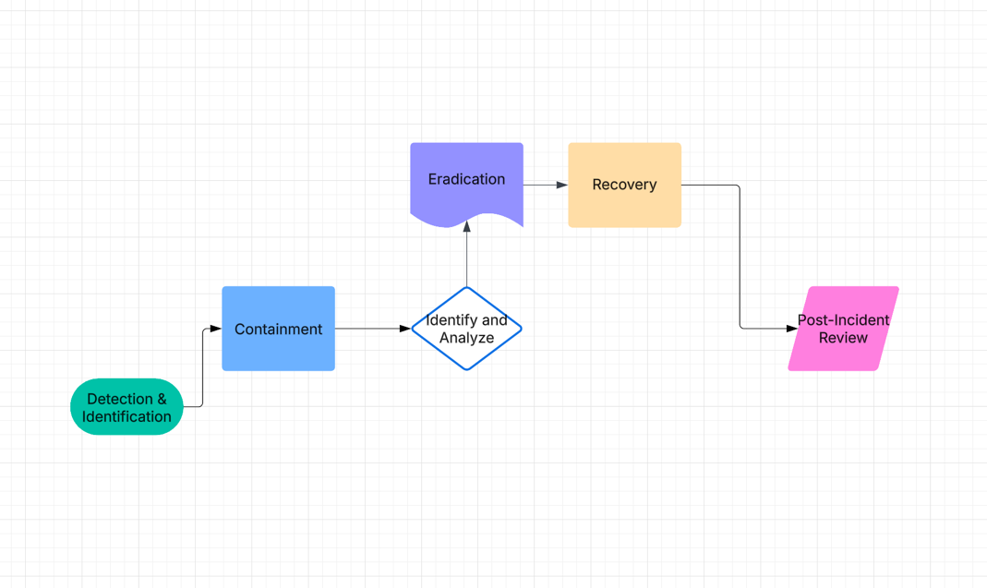
New Incident Flow Chart
Figure 1: Displays the new incident flow chart depicting how a breach would be handled.

References

Borkar, P. (2024, November 2). Incident response: 6 steps and the teams and tools that make them happen. Exabeam. https://www.exabeam.com/blog/incident-response/incident-response-6-steps-technologies-and-tips/
Tully, R. (2024, February 28). Who is responsible for Data Security & Compliance. Spirion. https://www.spirion.com/blog/who-responsible-data-security-management-compliance#
Wang, B. (2022, February 13). 7 most common types of cyber vulnerabilities. CrowdStrike. https://www.crowdstrike.com/en-us/cybersecurity-101/exposure-management/cyber-vulnerabilities/

